Assignment 9 Joonha Yoon

[Recursive algorithm]

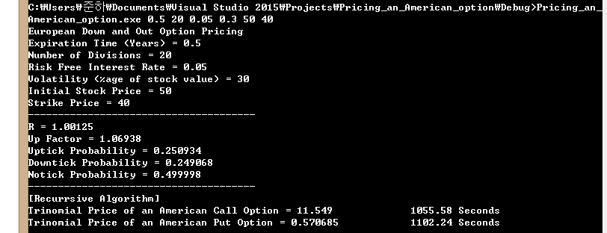

[Dynamic programming]

